Bolatkhan Akylbek

Theme: Restaurant Menu

Link to my git: <https://github.com/Akyldevil>

**Task 3. Create website theme using Bootstrap (third week)**

Bootstrap theme should provide at least 3 web pages. For example:

* Main page (Home page),
* News page;
* Products page;
* Registration page;
* Template of admin panel (admin page);
* Gallery pages, Slideshows;
* Contacts
* etc:

Some Mandatory Features:

1. Responsive Layout using Bootstrap Grid system
2. Clean Code (coding style, comments and others)
3. Easy to Customize
4. Built with Bootstrap 3, Bootstrap 4 and Bootstrap 5

**Part-2.**

**Answer following questions (10-points):**

**Questions.**

1. Main features of single-page website.

2 Advantages and disadvantages of the single-page websites.

3. Main features of multi-page website.

4. Advantages and disadvantages of the multi-page websites.

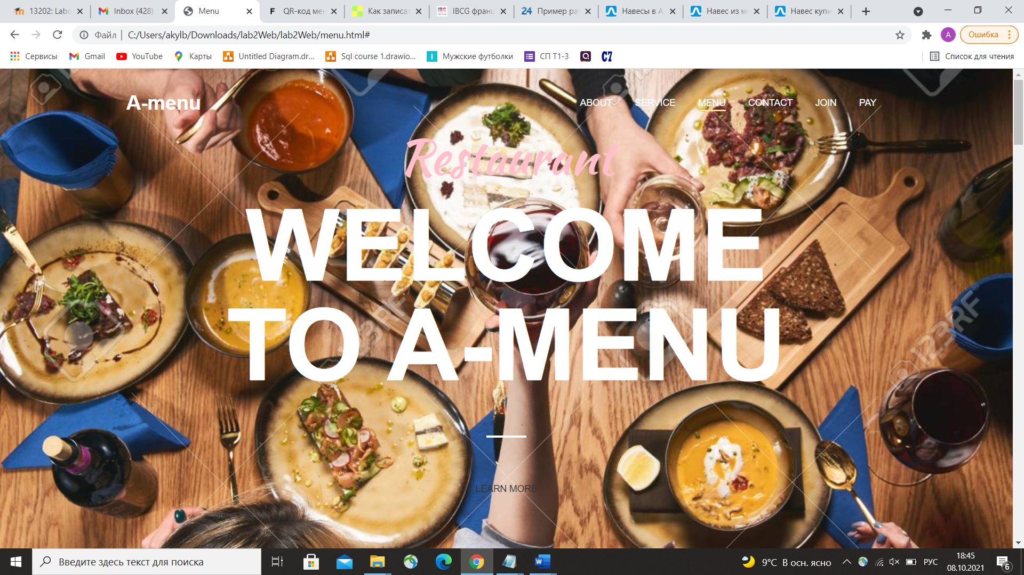

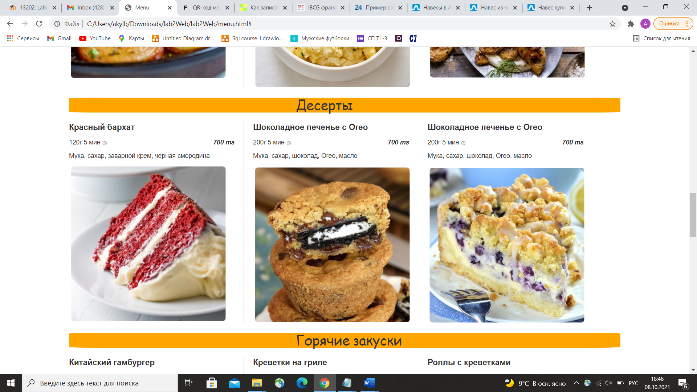

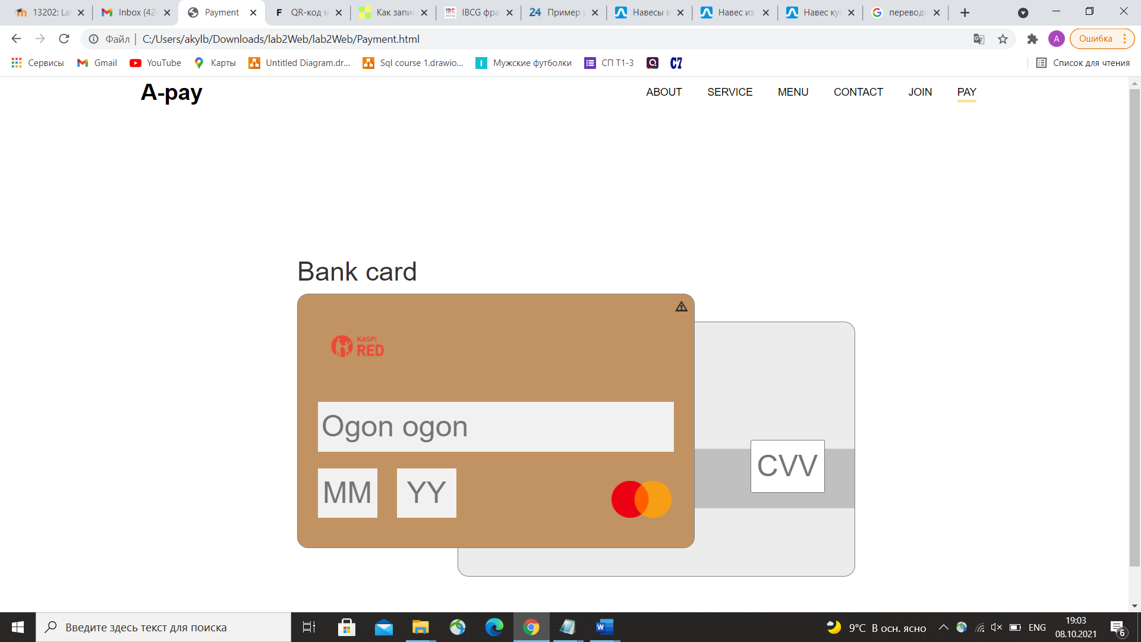

**Report**

In this laboratory 2.3 work we had started to develop our first web page from the project based on HTML and CSS

In introduction, a page layout defines the appearance of a website, in our case, it must be appeared restaurant menu. An HTML layout is a structure that helps the user navigate through web pages easily – for example, to find dishes which he wants. It is a way in which you can design web pages using simple HTML tags. Moreover, it is begun to become acquainted with payment systems in such sites.

We had used our knowledges from previous laboratory works, in addition, we had used tags(div – opening and closing). Also, practicing of attributes, elements, links and using of selectors, properties and values was learned in our laboratory work. In addition, using of bootstrap themes, else gives us new opportunities to increase our level of building of such sites.

To conclude, starting to create our projects main, menu and payment pages opens new properties, with which we can use right now, for instance, show to customers our pages, and say like “Вот так могу, и так могу”, for gaining of first orderings.